CONFERENCE PROGRAMME
ECC 2024 and ECP 2024
Introduction
10 Top Reasons Why You Should Visit Crete Island, Greece in the context of our Conference!

Why Crete ?
The biggest island of Greece is a charming place where you can enjoy your trip in the way you have imagined it. Here are 10 reasons why Crete is worth visiting; once you get there though, expect to discover many more!
1. Civilisation & Culture
Its strategic location on the map has turned the island into a crossroads where people and civilisations have left a permanent mark on, along with a rich cultural heritage. Across the ages, Minoans, Mycenaeans, Ottoman Turks, Arabs and Venetians have shaped the island’s identity.
So, discover Crete’s eventful history that spans fifty-odd centuries: the Minoan palaces at Knossos, Phaestos, Malia and Zakros; the archaeological sites of ancient Gortyna, Eleftherna, Lyttos, Aptera, Falasarna, Spinalonga; the Venetian harbours at Chania, Heraklion and Rethymno towns; the ottoman monuments and architectural structures seen across the island; the historic monasteries of Arkadi, Preveli, Toplou, Agarathou, and Chrysoskalitissa; numerous thematic museums – the Heraklion Archaeological Museum is among the most significant in Europe.
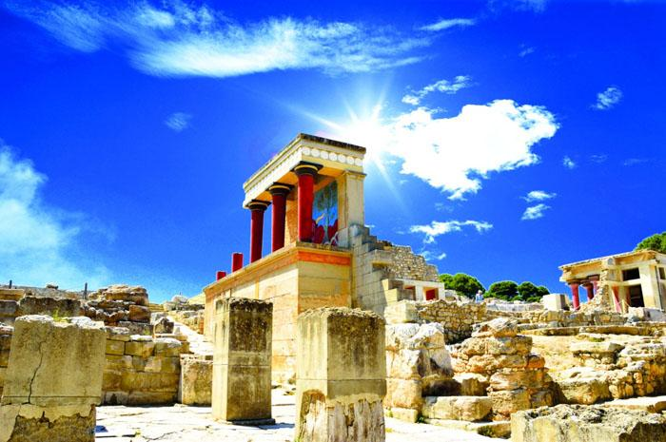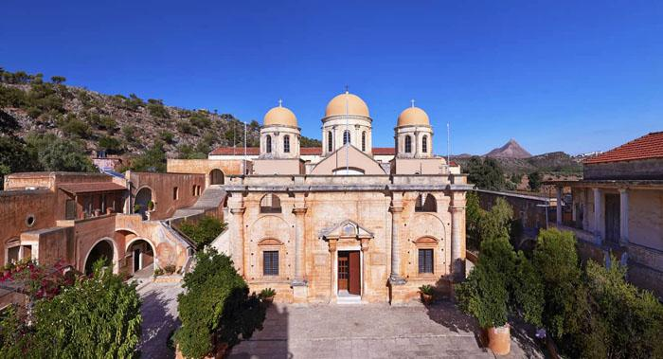
2. Old Towns
The old towns of Chania and Rethymno share a fascinating combination of Venetian and Ottoman architectural elements. They are well-known, charming, and much-photographed with an ambience reminiscent of times gone by. Stroll along their narrow alleys and streets, stop by and have a coffee, snack or meal in the traditional cafes and tavernas; the magical patina of old times is everywhere.
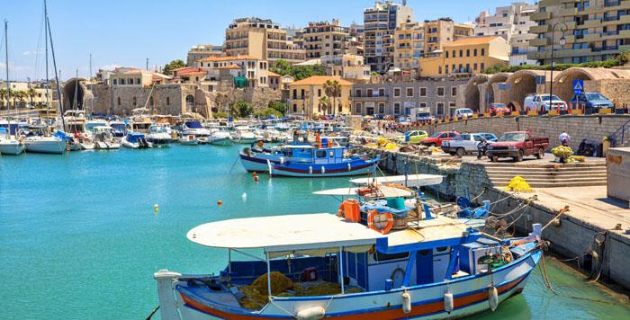
3. Traditional Villages
They are mountain villages, mostly. Old customs and traditions are kept unchanged and they unveil aspects of the true Cretan culture. Visit Archanes, Zaros and Asites in Heraklion region, Vamos and Chora Sfakion in Chania region, Anogeia, Axos and Margarites in Rethymno region, Makrygialos and Kritsa in Lasithi region. This is the ‘heart’ of traditional Crete.
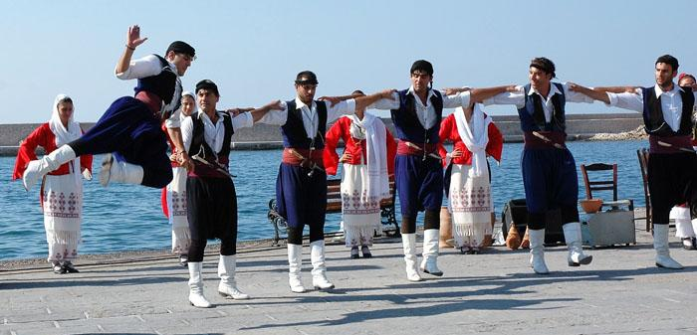
4. Seaside Tourist Resorts
Luxury resorts and lodgings of all types can be found along the seafront. Big towns such as Heraklion, Chania, Rethymno, Agios Nikolaos, Siteia and Ierapetra are not the only destinations that can offer you a vacation to remember: visit also Agia Pelagia, Amnissos, Kaloi Limenes, Chani Kokkini, Malia and Ammoudara (Heraklion region); Platania, Agia Marina, Kolympari, Agia Roumeli, Loutro, Palaiochora and Kissamos in Chania region; Georgioupoli, Bali, Plakia, Agios Pavlos, Panormos in Rethymno region; Elounta, Plaka, Makrygialos, Koutsounari, Agia Fotia in Lasithi region.
5. Gastronomy
The essence of the Cretan cuisine can be described in the following words: “prefer the products of your land”. The way locals make use of their land’s rich produce is remarkable. The wide variety of seasonal fruits and vegetables, legumes, wild edible greens and fragrant herbs are combined with tasty goat and sheep meat: the outcome is a number of particularly tasty dishes that don’t come up anywhere else in Greece. The local cheese list is also quite impressive; on the top you will find the popular Cretan graviera (a type of hard cheese) which is a PDO cheese.
6. Beaches
The island’s endless coastline features numerous beaches, most of which are sandy. Balos, Falasarna and Elafonisi are three beaches of great beauty in the region of Chania. Within a short distance from Heraklion you will find Amnissos, Agia Pelagia, Kaloi Limenes, Malia, Limenas Chersonisou, Ammoudara beaches. Don’t miss out on visiting Matala beach known since the sixties and seventies as a hotspot for hippies who travelled there from all over the world.
In Rethymno you will find the longest sandy beaches (Episkopi, Petres) and a number of quite unusual beaches (Triopetra, Agios Pavlos, Ligres, Fragokastelo, Preveli). The area of Lasithi is well-known for its picturesque shores that are washed by the Libyan Sea, as well as for cosmopolitan Elounta beach.
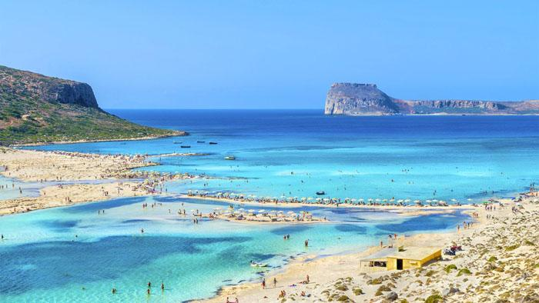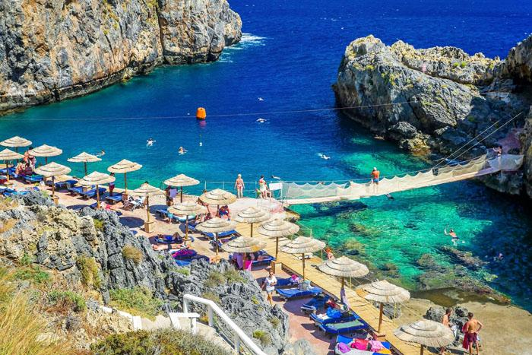
7. Nature’s Amazing Creations
The terrain’s morphological diversity is remarkable and it offers hard-to-ignore opportunities to daring explorers and nature lovers for extensive tours of the countryside. High mountains with rugged peaks, caves and ravines, fertile plateaus and valleys, rare cedar forests and water habitats are the pieces that make up the lovely and diverse Cretan land. Make a note of visiting Mt. Psiloreitis (or Psiloritis) Natural Park and Siteia (or Sitia) Natural Park - both are UNESCO Global Geoparks, discover caves celebrated in ancient Greek mythology such as Idaion Antron, Diktaion Antron, Melidoni and Sfendoni, hike along Samaria gorge, enjoy a ramble in Vai palm forest, Lakes Kourna & Preveli, as well as on Lasithi and Nida plateaus.
8. Activities
Crete is an island that can offer many a thrill to action-loving travellers by the sea or on the mountain. Hike through its ravines, enjoy your off-road rides in the mainland, follow the trekking routes – the landscapes crossed by the E4 European trail are amazing; enjoy water sports activities such as sailing, diving, sea kayaking and windsurfing.
9. Paradise Islands
Visit Gavdos islet, the southernmost tip of Europe; swim by heavenly beaches such as Sarakiniko, Ai Giannis, Pyrgos, Potamos, Trypiti; discover cedar woods that reach the seashore and well-tended trails that lead to the few island villages. In the summertime the place is a popular camping spot. There is a boat connection with Palaiochora, Sougia and Chora Sfakion.
Chrysi or Pontikonisi islet (8 miles south of Ierapetra) is a feast for the eyes, with its turquoise waters, the off-white sands enriched with the hues of broken seashells, and the huge seaside cedars rooted in the sand dunes. Every day hundreds of visitors come to the island for a day trip aboard the tourist boats from Ierapetra. Chrysi islet has been designated a Natura 2000 area and it is strictly forbidden to camp and spend the night there.
Koufonisi, Siteia (or Lefki islet) is a place that few people know. There are caves shaped in the limestone rocks that contain vestiges of significant antiquities. The sandy beaches and natural serenity is what makes this islet a paradise - one that only locals are aware of; they usually take a trip there using their own boats. There is however a small boat that will take you from Makrygialos to Koufonisi. This islet is a pristine area with no facilities of any kind, so make sure you carry the essentials for your trip with you.
10. A Natural Way of Life
The Cretans are proud and affable people. They are, after all, the descendants of Cretan-born Zeus the god of hospitality and father of all ancient Greek gods. And they know how to offer hospitality to strangers in their parts. Their profound love for their homeland and their adherence to traditional ways and customs have shaped a special culture and a way of life that is absolutely worth discovering. And if you happen to be invited to a Cretan feast, you will feel what it’s like to have fun - the way locals do. You will savour tasty titbits and dishes, and you’ll be called to join in the folk dances; you will listen to mantinades (songs with words improvised and sung on the spot) and rizitika songs. Have a great time – the Cretan way!

CONFERENCE PROGRAMME
OSTRIA HOTEL (5 Star)
Katharades, Ierapetra,
72200 Crete, Greece
www.ostriahotel.gr
+302842025711 +306974938456

Tuesday, May 7, 2024

09.00-16:00 (working hours of the Secretariat)
Registration
Distribution of the Conference bags
* Certifications of Presentation and Receipts (Invoices) will be sent to you only by email

The presentations will appear here (after the conference)
https://www.interbit-research.com/presentations.html

Conference Room A'

Time: 10.00-10:20
Advanced fuzzy logic controllers design and evaluation for buildings’ occupants thermal–visual comfort and indoor air quality satisfaction
By Emmanuel Antonidakis

Time: 10:20-10:40
Singularities in Solid-Liquid Turbulent Flow
by Artur Bartosik

Time: 10:40-11:00
Efficiently modeling and controlling complex dynamic systems using evolutionary fuzzy cognitive maps
By Emmanuel Antonidakis

Time: 11.00-11:20
A Comparative Analysis of Energy-Efficient Short-Range Wireless Data Communication Protocols
By Manolis Tampouratzis

Time: 11:20-12:00
Artificial Intelligence and Robotics - Challenges and trends
By Marios Sfendourakis

12:00-12:30
Welcome Cocktail and Coffee Break

Conference Room A'

Time: 12:30-12:50
Dose Effect Models for Space Radiobiolgy : An overview on dose effect relationship on behalf of the AMS SPRB Collaboration
By Alessandro Bartoloni

Time: 12:50-13:10
Real time observation of a stationary magneton
By Emmanuel Antonidakis

Time: 13.10-13:30
Two isomorphic forms of quantum e.-m. field existence and Lamb and Casimir effects
by Aleksander Beilinson

Time: 13:30-13:50
CFD analysis to optimize air quality in aeroponic tower garden
by Esam Jassim, Bashar Jasem, Faramarz Djavanroodi

Time: 13.50-14:10
Simulation modeling of the operation of the toll plaza with reverse lanes
By Alexander Talavirya, Michael Laskin

Time: 14.10-14:30
COVID Pneumonia Severity Detection of Chest CT-Scan Images based
on Robust Semantic Segmentation
by Bayan Alsaaidah

Time: 14.30-14:50
Development of Portable Electronics Incentive Spirometer for Patients Recovering from COVID-19 for Nakhon Nayok and Sa Kaeo Province Community
By W.Senavongse and S.Noimanee

Time: 14.50-15:10
Design of Smartwatch with Non-Invasive Blood Glucose Monitoring Using an I2C Ultra-Slim Low Voltage Sensor
by K.Noimanee and S.Noimanee

On-line Presentations
On-line Session I:
Applied, Numerical and Computational Mathematics in Physics and Engineering
14:40-18:00

Federico Bartolozzi | Frequency Commutability In Earthquake Isolation System
Armando Trento, Paolo Fiamma | Collaboration Mediated by Intelligent Filters Across Different Design Semantics
Sudha M, Irfan Ahmed M S | Machine Learning In Cardiology: Comparative Analysis Of Post Angioplasty Myocardial Infarction Prediction Models
Tahar Mehenni | A multilingual chatbot for supporting mobile companies complaints
Rajesh Dhayal | Controllability results for fractional differential equations with impulsive effects
Kritik Sharma, Harsh Sangal, Salim, Varun Gupta | To Design and Implement a Machine Monitoring Module using PLC for Small Scale Industry Machines
Aneesh B S, K Aditya Shastry, Chinmay M P, Gowtham Patel C, Shashank G N | Deep Learning Based Cyclone Intensity Estimation
Ulviyya Mammadova | Remote Sensing Study of Total Solar Energy Potential in the Dagligh Shirvan Economic Region
Okuyade Ighoroje Wilson Ata | MHD Mixed Convective Fluid Flow through Two Parallel Vertical Plates Channel
Rajendra Kaduskar | Online Education Styles: Challenges and Coping Mechanisms
Ahmed Kanber | Finite difference scheme for transport-diffusion-reaction of antibodies in a tumor : Analysis of consistency and stabilité
Rajeev Tripathi | Adoption of a Refined Text Classification Method Using the Laravel Framework
P.V.V. Rama Rao, D. Chandra Sekhar | Unified Power Flow Controller for Optimal Performance of Solar-Wind Energy Integrated System
Shridhar Kumar, Pratibhamoy Das | Optimal and Higher Order Convergent Analysis for Nonlinear & Boundary-Interior Originated Mixed Boundary Value Problems with Non-smooth Data
S Radha, P Nagabushanam, J Jayakumar, Jala Prakash Kumar, Poonam Upadhyay | Statistical Analysis and electric range distributions in battery EVs and hybrid EVs

19:00-21:00
Conference Dinner

CONFERENCE PROGRAMME
OSTRIA HOTEL (5 Star)
Katharades, Ierapetra,
72200 Crete, Greece
www.ostriahotel.gr
+302842025711 +306974938456

Wednesday, May 8, 2024

On-line Presentations

On-line Session II: Simulation and Computational Techniques
08:00-11:00
Speakers | Paper
Shanfang Huang, Junren Hou | Finite volume lattice Boltzmann method based on OpenFOAM
Preeti Khorjuvenkar, Shawn Pinto, Sameer Patil,Delissa De Ataide, Marlon Sequeira, Jivan Parab | Machine Learning-Based Prompt Detection of Chili Plant Disease on smart phone using PaaS cloud
Bayan Alsaaidah | COVID Pneumonia Severity Detection of Chest CT-Scan Images based on Robust Semantic Segmentation
Sidra Ghayas, Suboohi Safdar, Junaid Sagheer Siddiquie, Asif Mansoor | A comparison of artificial neural network and principal component analysis for major source of deterioration COD in Manora channel water quality.
Francesco Tornabene, Matteo Viscoti, Rossana Dimitri | Higher order equivalent layer-wise theory for the multifield analysis of smart laminated shell structures
Michael Laskin | Simulation modeling of the operation of the toll plaza with reverse lanes
Candidus .U Eya, Ugwuijem Chikadibia Daniel, Uzoma Stephen Egesimba, Ezike Morris Obiora, Lukumba Phiri | Harmonic Reduction in Two-level Power inverter using Enhanced-Direct Current (DC) Based- Modulation Technique
Pengjiu Li, Hirohisa Sakai | Equipment Reliability Process with Predictive Maintenance (PdM) Technology: Advanced TPS Based upon Highly Reliable Lean Maintenance at Toyota Manufacturing USA
Prabjot Kaur & Ashitosh Tiwari | A Hybrid Model For Vendor Selection Problem Using Multi-Criteria Decision-Making(Mcdm) & Machine Learning
Marta Alić | Coding the Efficient Privacy Policy: Striking a Balance Between Lexical Density and Readability
Carlo Boldrighini, Sandro Frigio, Pierluigi Maponi, Alessandro Pellegrinotti | Computing a class of Blow-up Solutions for the Navier-Stokes Equations
Luçiana Toti, Alma Golgota | Improving the performance of the photovoltaic system with optimization algorithms: the case of Durres’ University
Nadir Muru | Pell hyperbolas in DLP–based cryptosystems
Oladapo James, Idowu Janet, Owolabi Timothy, Ayinde Kayode, Adejumo Joel | A New Ridge Type Estimator in the Logistic Regression Model with Correlated Regressors.
Kartik Chandra Patra, Asutosh Patnaik | Quenching and Suppression of Limit Cycles in 3x3 Nonlinear Systems
Manab Biswas, Debashis Kumar Mandal | On the growth rates of composition of integer translated entire and meromorphic functions
Muhammad Redzuan Suhairi | Internet of Things: Cyberattack detection based on Energy Consumption
Mahmoud M. El-Borai and Khairia El-Said El-Nadi | On the construction of a new fractional Brownian motion
On-line Session III: Applied and Numerical Mathematics
11:00-14:00
Maja Sarevska, Rexhep Mustafovski | Overview of Data Structures Comparison for Element Deletion
Swaswati Purkayastha, Kandarpa Kumar Sarma and Nikos Mastorakis | Spread Spectrum Modulation Combined with AI in for Jamming Resistant Communication
Atlanta Choudhury, Kandarpa Kumar Sarma and Nikos Mastorakis | AI- based Text to Scene Generation as part of a Pandemic Compliant Infrastructure
Syed Mohamed E, Yasmin Regina M. | Modelling of Tsunami Wave Generated by Volcanic Eruption Using Impulsive Disturbance for 2022, Tonga Island Tsunami
Syed Mohamed E, Yasmin Regina M | Computational Analysis To Forecast The Tsunami Wave Run-Up Phase Using TIMPULSE-SIM Model With Case Studies
Ismail Assoujaa, Siham Ezzouak | Enhancing Cloud Security: Strategies and Technologies for Protecting Data in Cloud Environments
Safiye Turgay, Esma Sedef Kara, Çiğdem Cebeci | Fuzzy Optimization for Closed-Loop Reverse Logistics: Towards Efficient Resource Management
LN Das, Ritesh Dabas, Riya Jain | Modified Energy-Efficiency Layered Routing Scheme (ELRS) for Wireless Sensor and Actuator Networks
Kun Ma, Haobo Shie, Tian Swee Tana, Muhammad Amir As Ari, Yan Chai Hum, Wei Huang, Kah Meng Leong, Matthias Foh Thye Tiong, Jahanzeb Sheikh, Zhibo Wen | The Predictive Value of Non-enhanced CT Radiomics in Improving Early and advanced T Staging of Colon Cancer
Antonio Pesqueira | Synergistic AI-Big Data Insights for Enhanced Biomedical Discovery
Abdelhamid Tadmori | Chaotic encryption using Braille codes and elliptic curves
R. Akhrif, A. Kouibia, L. Omri and H. Oulad Yakhlef | Approximation method by variational splines of Moroccan s Covid data
Tanishq Kohli, P.R.Selokar | A Comprehensive Walk-Through on Data Acquisition Utilising Amazon AWS IOT Core and MQTT.
W.I.A. Okuyade | MHD Mixed Convective Fluid Flow through Two Parallel Vertical Plates Channel
F.G. Lupianez | On Covering Properties in Intuitionistic Fuzzy Topological Spaces: A survey
Mahmoud Jahjouh, Uneb Gazder, Rashid Abdulrahman Ismaeel | Development of Traffic Microsimulation Tool with the Incorporation of Variations in Driver Behaviours
Jatoth Rajender, Manisha Dubey, Yogendra Kumar | Grid-connected PV Array with Boost Converter and Synchronous Control
Kartik Chandra Patra, Asutosh Patnaik | Quenching and Suppression of Limit Cycles in 3x3 Nonlinear Systems
Break: 14:00-17:00

On-line Session IV: Applied and Computational Mathematics
17:00-20:00
Andrey Belousov, Ekateryna Belousova | Integration of Nanotechnological Agent (MICROMAGE-B) in Multicomponent Treatment of Multiple Sclerosis
Andrei-Florin Albisoru, Dorin Ghisa | Complex analytic functions with natural boundary
Georgios Rigopoulos | Investigation on Factors Influencing Perception for Cryptocurrencies Adoption
Chandani Sharma, Pankaj Jha | Impact of Unemployment on Economic Growth Before Covid Versus During Covid-19 (2020-2021)
Valeriy Perminov | Mathematical Modeling of Forest Fire Prevention Using Firebreaks and Barriers
Serhii Gryshchuk | Biharmonic continuations of gradients via monogenic functions with values in biharmonic algebra
William Aparecido Celestino Lopes; Adilson Cunha Rusteiko; Cleiton Rodrigues Mendes; Nicolas Vinicius Cruz Honório; Marcelo Tsuguio Okano | Developing a Virtual Simulation for Optimising the Validation Process in Automotive Industry Projects
Farida Achemine | Solution Concept for Bimatrix Games with Fuzzy Random Payoffs
Vitaliy Pavlenko, Tetiana Shamanina | Identification of the Oculomotor System on base Volterra Models: Application in Biometric Authentication System
Alessandro Pagano, Vita Santa Barletta | Revolutionising Learning Analytics with Quantum Computing: Challenges and Strategies
Natalja m. Matsveichuk, yuri n. Sotskov, liangliang sun | Optimal Scheduling Works for Two Employees with Ordered Criteria
Sidra Ghayas, Mahreeil | Application Of Artificial Neural Network For The Complex Data Structures In The Diagnosis Of Depression
Vivek Nikam, Goran Rafajlovski, Saiful Islam, Michael Hartmann | Optimal Sizing of Microgrid with Mathematical and Meta-heuristic Optimization
Diego Falconí, Secundino Marrero | Methods for Determining Similarity and Distance Between Researchers Using Classification Algorithms
Paula Escudeiro, Márcia Campos | Quantitative Evaluation Framework: A Paradigm for Assessing the Quality of Digital Educational Content
On-line Session V: Applied and Computational Mathematics in Science and Engineering
20:00-23:00
Hamit Alyar, Saliha Alyar, Imad Ali Talab | investigation of spectroscopic and electronic properties of 2-hydroxyacetophenone methanesulfonylhydrazone by dft method
Georgios Rigopoulos | A Machine Learning Credit Assessment Model with Selective Feature Extraction for Thin Credit History
Danish Hassan, Kashif Javed, Usama Raza, Syed Abdul Wasay Ali | Analyzing COVID-19 Spread Using AI: Insights from Seven Countries Data
Raja Mohammad Latif | Soft Compactness, Soft Connectedness and Soft Separation Axioms via Soft Generalized αii-Open Sets in Soft Topological Spaces
Raja Mohammad Latif | Soft Semi#gα-Separation Axioms in Soft Topological Spaces
Rajesh Dhayal | Controllability results for fractional differential equations with impulsive effects
Syed Mohamed E, Chithirai Pon Selvan M | Computation Models for Tsunami Wave Propagation Using Extended Cellular Automata
Samira Nascimento Antunes, Madalena De Oliveira Barbosa Divino, Luana Dos Santos Cordeiro, Fernanda Pereira Leite Aguiar, Marcelo Tsuguio Okano | Evaluating Aromatic Herbs Classification Using Convolutional Neural Network and Transfer Learning

CONFERENCE PROGRAMME
OSTRIA HOTEL (5 Star)
Katharades, Ierapetra,
72200 Crete, Greece
www.ostriahotel.gr
+302842025711 +306974938456

Thursday, May 9, 2024

On-line Presentations

On-line Session VI: Applied and Computational Mathematics in Science and Engineering
08:00-11:00
Taku Onishi | Quantum Wavefunction Analysis for Hydride Ion Conducting Materials
Ajoy Kanti Das | A novel hybrid approach using hesitant bipolar fuzzy soft sets for enhanced group decision-making
Harish Dutt Sharma, Sanjay Mishra, Parminder Singh, Manisha Saini, Ruby Faizan, Yogesh Juyal | A Documentary that Explores Virtual Reality and its Impact on Education
Preet Kaur | Design & Analysis of ENG Metamaterial Embedded Subwavelength Patch Antenna
Pooja J N, VaniI H Y, Anusuya M A | Mental illness Detection through Audio Data
Ivan Keča, Alen Šimec | Comparison of similar languages in object orientation environment
Ajoy Kanti Das | Optimizing decision-making through a novel hybrid approach with hesitant bipolar fuzzy soft expert system
Safiye Turgay | Cognitive Modeling for Effective Emergency Response: An Agent-Based Simulation Architecture
Victor Okolnishnikov, Sergey Rudometov | Simulation environment MTSS and its applications
Irfan Samrizan, Samsuri | Resilient of University Library: Perspectives of Students towards University Library
Prakash Anand | Offline Hand-Written Roman Text and Signature Recognition using Convolutional Neural Network in Python with TensorFlow
Kun Ma, Haobo Shi, Tian Swee Tan, Muhammad Amir As Aria, Yan Chai Hum, Wei Huang, Kah Meng Leong, Matthias Foh Thye Tiong, Jahanzeb Sheikh, Zhibo Wen | The Predictive Value of Non-enhanced CT Radiomics in Improving Early and advanced T Staging of Colon Cancer
Vinod Kumar Verma, Saurabh Sharma | Self-Organizing Maps Based Investigations on Machine Learning Enabled Internet of Things
Golsa Sarvari, Ali Sadollah | Topology Optimization Integrated with Finite Element Analysis for 3D Problems
Waly FallL, Modou Badiane, Prince Abdoul Aziz Honadia, Fabé Idrissa Barro | Intelligent Energy Metering in the Smart Grid : A Review
Carlos Lastre-Domínguez, Victor Jiménez-Ramos, Cesar Hernández Sánchez , Eduardo Pérez-Campos, Marco Sánchez-Medina, Jorge Muñoz–Minjares | Classification of ECG Signals Based on Iterative UFIR Filter Estimated Features
On-line Session VII: Applied and Computational Mathematics in Systems Applications
11:00-14:00
Dijana Oreski | Machine learning-based predictive modeling of entrepreneurial intention
K.Anita Sheela,SM Pervez,M Vishnuvardhan, Ch Sathvika, J Sandhya | Navigating Geospatial-Thematic Data through NLP
K.Anitha Sheela,J Sandhya, M.Maahir, N.Sathwik | Sign Language Transformer using Spatial Representations
Sheetal Tanna, Shweta Shah | Various Trajectory Analysis for Spoofing Scenario in Navigation
G.V.R.K. Vithanage, Sophia R-J Jang | Optimal immunotherapy interactions in oncolytic viral therapy and adopted cell transfer for cancer treatment with saturation effects.
Md Afroz, Birendra Goswami, Emmanuel Nyakwende | Optimizing Urban Traffic Flow through Advanced Tensor Analysis and Multilinear Algebra: A Computational Approach to Enhancing Smart City Dynamics
Kaouter Labed, Sarah Benziane | Understanding Numerical weather prediction models
Maheswari R and Mohana N | Block-Chain Based Decentralized Waste Management System
Ilirjan Mallolari | Theoretical Calculations on Simultaneous Emission Removal from a Waste Gasification Plant
Diana Rubio | Application of Bidimensional Empirical Mode Decomposition for Particle Identification and Size Determination
Sarah Benziane | Understanding Numerical weather prediction models
Octavian Agratini | On increasing the rate of convergence for approximation processes

